**Abstract**

In this paper we have researched articles that are applicable to a system that records vehicle passing data for cyclists. Key areas researched include Arduino,  sensors, cyclist safety, cyclist and vehicle interactions, road design. By studying these topics we can gain a better understanding of the technologies we are using and the interactions cyclists have on the road.

**Key words**

Arduino, raspberry pi, sonar, infrared sensor, mobile sensing,

**1. Introduction**

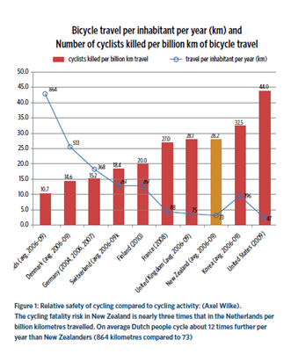Cycling is generally viewed as an environmentally and economically sustainable mode of transport, but cycling is also much more hazardous. The problems that cyclists face are that drivers are not thinking of cyclists safety, which leads to an increase of crash risk for both cyclists and vehicle users. The graph above shows that New Zealand has one of the highest mortality rates in the world among cyclists, this is shocking as the graph also shows New Zealand as being second lowest on cycling hours[1].  Factors that contribute to the problem of cyclist safety are vehicles passing too closely to cyclists, and/or passing too quickly. Our hope is to produce a product that produces data that can help to improve safety for cyclist and road users.

**2. Problem Statement**

The problem that we have been asked to solve is finding areas in Dunedin that are unsafe for cyclists and to collect data to show that these areas are unsafe for cyclists. Our client is aware of the problem of Dunedin being a reasonably unsafe place for cyclists and thinks that data showing the problem areas would be valuable. The main data that would be useful would be:

* The distance vehicles are passing too close to cyclists
* Where vehicles are passing too close to cyclists
* Speed
* Relative position of cyclist on the road

**3. Technologies**

**3.1 Microprocessors**

Microprocessors such as the Arduino and Raspberry Pi have proved to useful for prototyping             many different systems. Their size makes them portable, which is important for fitting them onto a bicycle or cyclists. Both systems are capable of using analog and digital input and output. Both systems can have also have external battery packs or power sources attached to them.We are using an Arduino for our prototyping because we already have some available to us and also we have experience in using an Arduino but we have never used a Raspberry Pi before. The Raspberry Pi is also more powerful than what we need it for currently.

**3.2 Sensors**

The system would need a way to detect if vehicles are in too close of a proximity to the cyclist or bike. There are several different types of sensors that could help us achieve our goal of distance detection.

One of the first devices we looked at was a infrared distance detector. While infrared sensors are generally a lot more accurate, they have several downfalls which make it not viable for our project. Most infrared sensors have a very short maximum range. “For instance, the SRF05 ultrasonic sensor can clearly detect objects up to 4 m away, whereas the Sharp GP2D12 infrared sensor that we’ll use in this chapter has a maximum range of 80 cm.”[2] . Our product will also be mainly used outside, which means that light will play a major factor in the accuracy of infrared detector. “It relies on light, so in bright direct sunlight, infrared sensors often won’t work well, if at all—sunlight will saturate the sensor, creating a false reading.”[2]. Because of this reason we have decided against using a infrared sensor on our device.

The other way of detecting distances we came across was sonar sensing. This method of  distance measuring seems the most sensible, as the sensor can detect much greater distances, it will be easier to use outside because natural sunlight will not interfere with the readings. Problems with using sonar would be it is not as fast as infrared, therefore not as accurate. ”It works much more quickly than ultrasonic sensors because, as your intuition might tell you, light travels more quickly than sound. That means the danger of interference is much lower.”[2]. If needed we have also considered a combination of using both infrared and sonar sensors.

**3.3 Data Management**

Our device will require data to be stored on it. An Arduino has very small storage space on it by default, so we require another method to store the collected information. We decided on a SD breakout to attach onto the Arduino. This will easily allow us to store the information onto an SD card.

The data that we collect will need a way to be collected from the device. After some research we have found there are some options available to us. The first option we could use is to have a mobile modem on the Arduino to allow it to send the data off using the cellular network. This would require a mobile data plan so leads to monthly costs. After researching a similar device it showed that using this method would use a very small amount of data, so would only require the smallest data plan “The MSB generates 1600 bytes/minute of data when sampling every 5 seconds. With an average driving time of 2 hours per day for 30 days, the MSB produces about 5.5 MB of data per month, which is a small fraction of a typical low end data plan.”[3]. Another option for us is to connect the Arduino to the users mobile phone and send the data off, using a small portion of the their mobile data or waiting until they are in wifi range and then send the data off through their phone. The last option we have is to have the user connect the device into their computer and have the data sent off through their home network.

**4. Cycling Safety**

As cyclists are going to be the main users of our system we researched about safety when it comes to cycling to get a better understanding when it came to how cyclists are using the roads. Our device will be measuring how far away from the cyclists the vehicles are getting so we researched various factors that would be the cause behind the two getting close. Our research found that some of the reasons were that the cyclist may not have a choice and be forced out onto the road “Cyclists may ride away from the kerb or occupy a lane – not because they want to annoy drivers, but to:

-- avoid drains, potholes or roadside rubbish

-- be seen as they come up to intersections with side roads

-- discourage drivers from squeezing past where it’s too narrow.”[1].

We are hoping that the data collected by our device will be able to be used to help improve the roads and possible add cycling lanes to areas that prove to be particularly hazardous to cyclists. It has been shown that having cycling lanes will reduce the number of crashes “The overseas research indicates that the number of crashes decreased when on-roadway cycle lanes were installed; the reduction of cyclist crashes generally varied from 35% to 50%, although one source did report an increase in cyclist crashes. Total (cycle and motor vehicle) crashes were found to decline by 6.5% to 35%.”[5].

Many different variables could come into play that could affect the readings that our device could gather, from weather to the cyclists competence and even the type of vehicles that pass the cyclists. Even the colour of the cyclists clothing can affect how close of a proximity a vehicle passes by them as shown from the graph down below .[6]

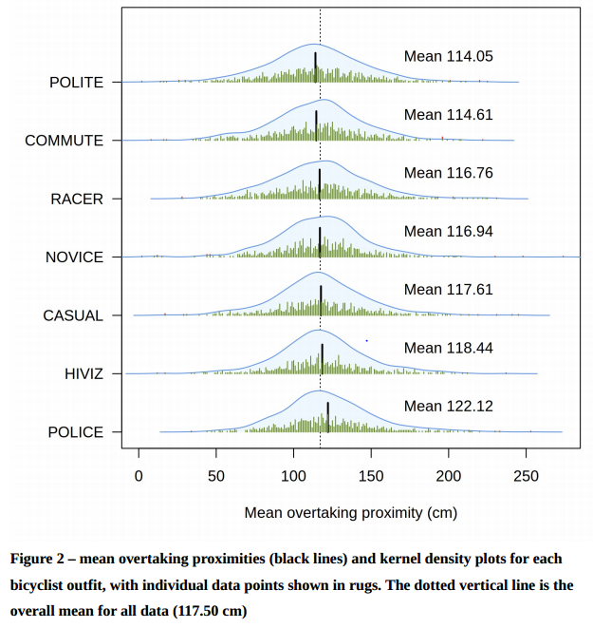

**Conclusion**

Our investigation on the topics of microprocessors, sensors, data management and cycling safety have helped us get a better understanding of how we need to proceed with our system. From this research we’ve found that we need to have a way of determining if there is a cause that is making the cyclist travel out into the road to make the passing distance of the vehicle close or if it is the fault of the vehicle driver. We also have a better understanding of the technologies we are using and which ones will be better to use for our prototype.

**References**

[1] Safety, C., Draft, P., & Document, C. (2014). Safer Journeys for people who cycle.

[2]Arbenz, M. (2011). In Action, (November 2010).

[3]Srinivas Devarakonda, Parveen Sevusu, Hongzhang Liu, Ruilin Liu, Liviu Iftode, Badri Nath.(2013). Real-time Air Quality Monitoring Through Mobile Sensing in Metropolitan Areas, Department of Computer Science, Rutgers University

[4]Turner, S. (2009). Cycle Safety : Reducing the Crash Risk October 2009. Cycle.

[5]Walker, I., Garrard, I. and Jowitt, F. (2014) The influence of a bicycle commuter's appearance on drivers’ overtaking proximities : an on-road test of bicyclist stereotypes, high- visibility clothing and safety aids in the United Kingdom. Accident Analysis and Prevention,

64. pp. 69-77. ISSN 0001-4575